Q1: 1. Exercise: Explore the relationship between the following, where x contains numbers

from 1 to 100:

x and x^2

x and x^3

x + y = 101

xy = 500

A1-:

x<-1:100

> plot(x,x^2)

> plot(x,x^3)

> y=101-x

> plot(x,y)

> y=500/x

> plot(x,y)

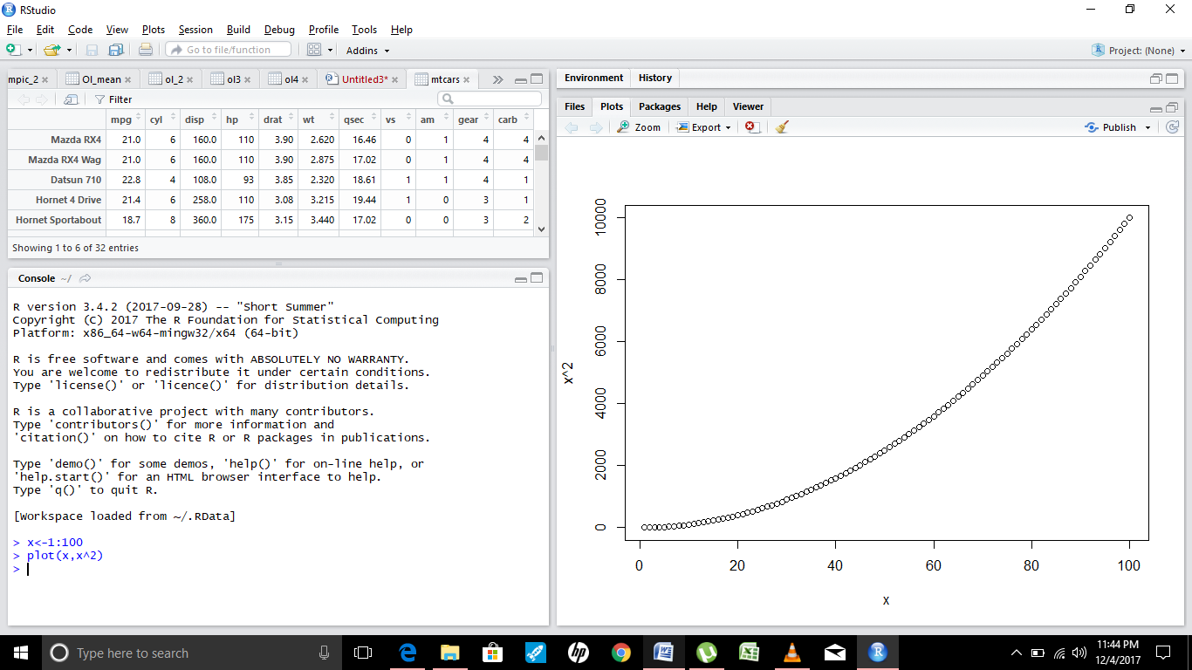

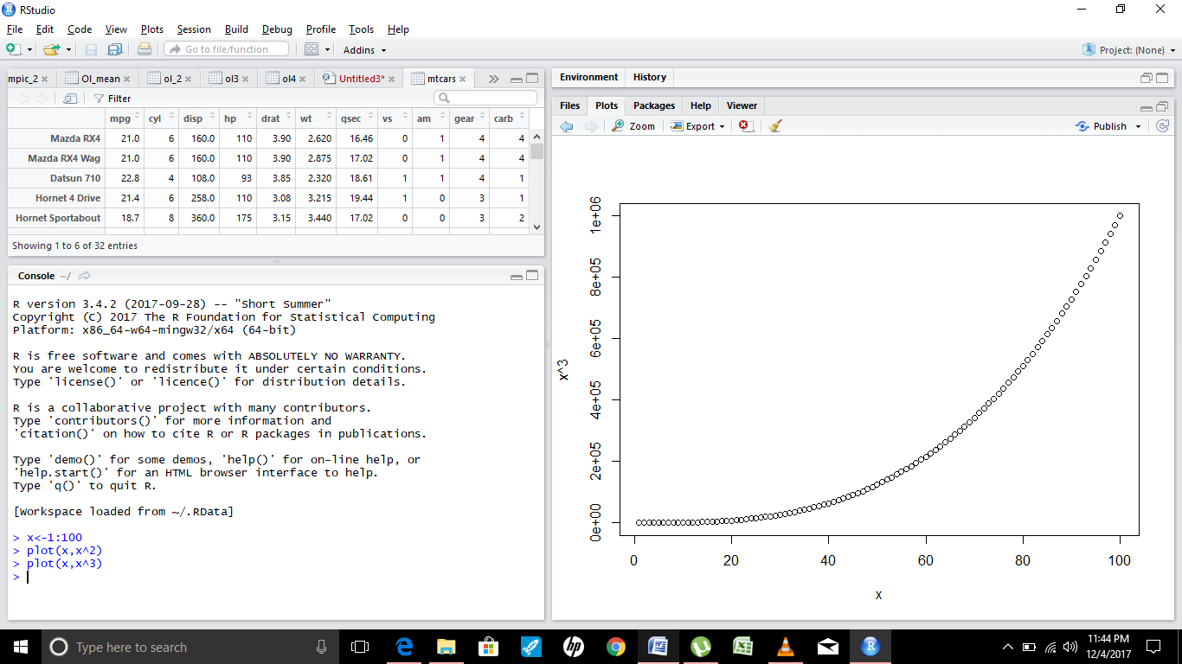  
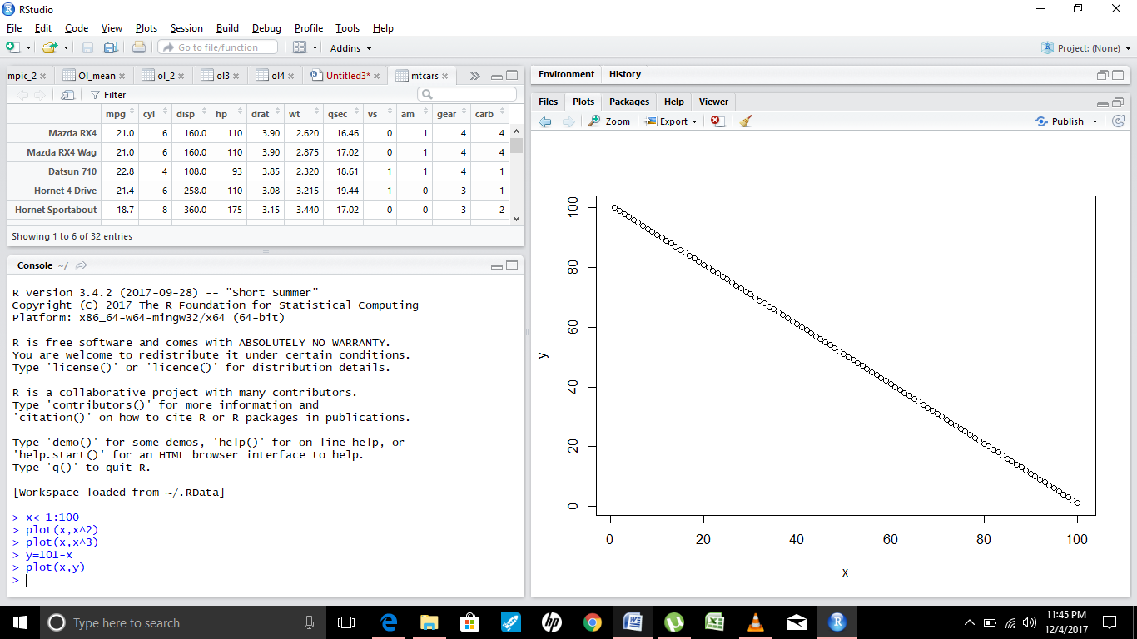

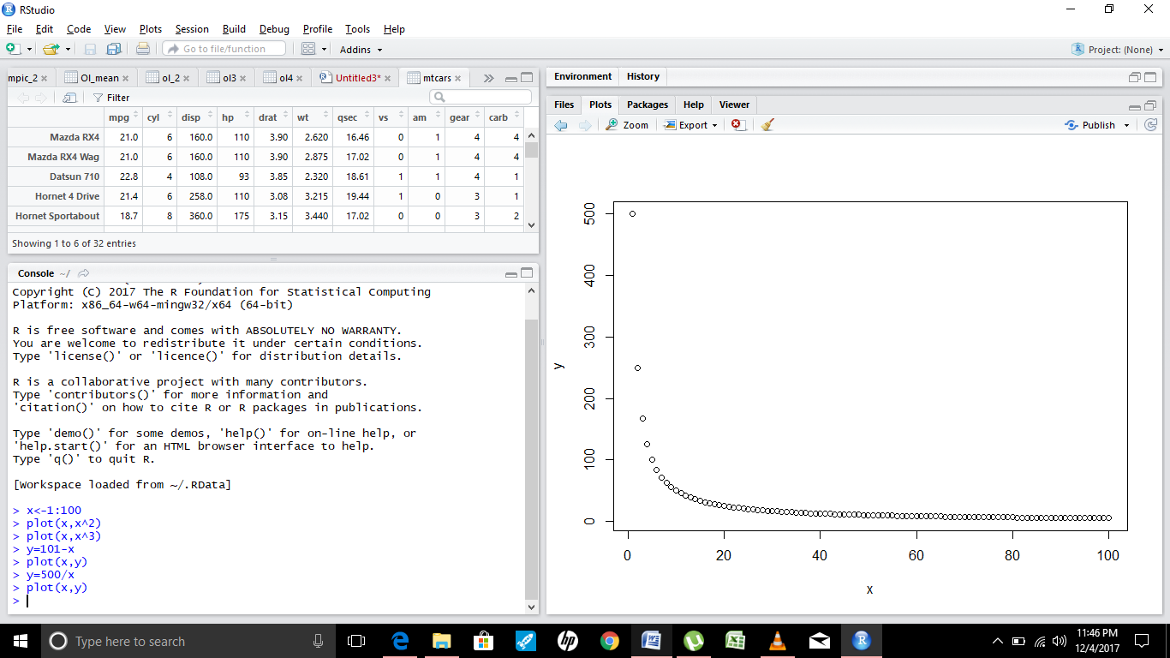

Q2. First we'll produce a very simple graph using the values in the car vector:

# Define the cars vector with 5 values cars <- c(1, 3, 6, 4, 9)

# Graph the cars vector with all defaults plot(cars)

Let's add a title, a line to connect the points, and some color:

# Define the cars vector with 5 values cars <- c(1, 3, 6, 4, 9)

# Graph cars using blue points overlayed by a line plot(cars, type="o", col="blue")

# Create a title with a red, bold/italic font title(main="Autos", col.main="red", font.main=4)

A2. A

plot(cars,type = "b", col="red")

title("Cars Vector")

A2.b.

plot(cars,type = "o", col="blue",pch=3)

title("Cars Vector")

A2.3

title("Cars Vector", col.main="red", font.main=4)

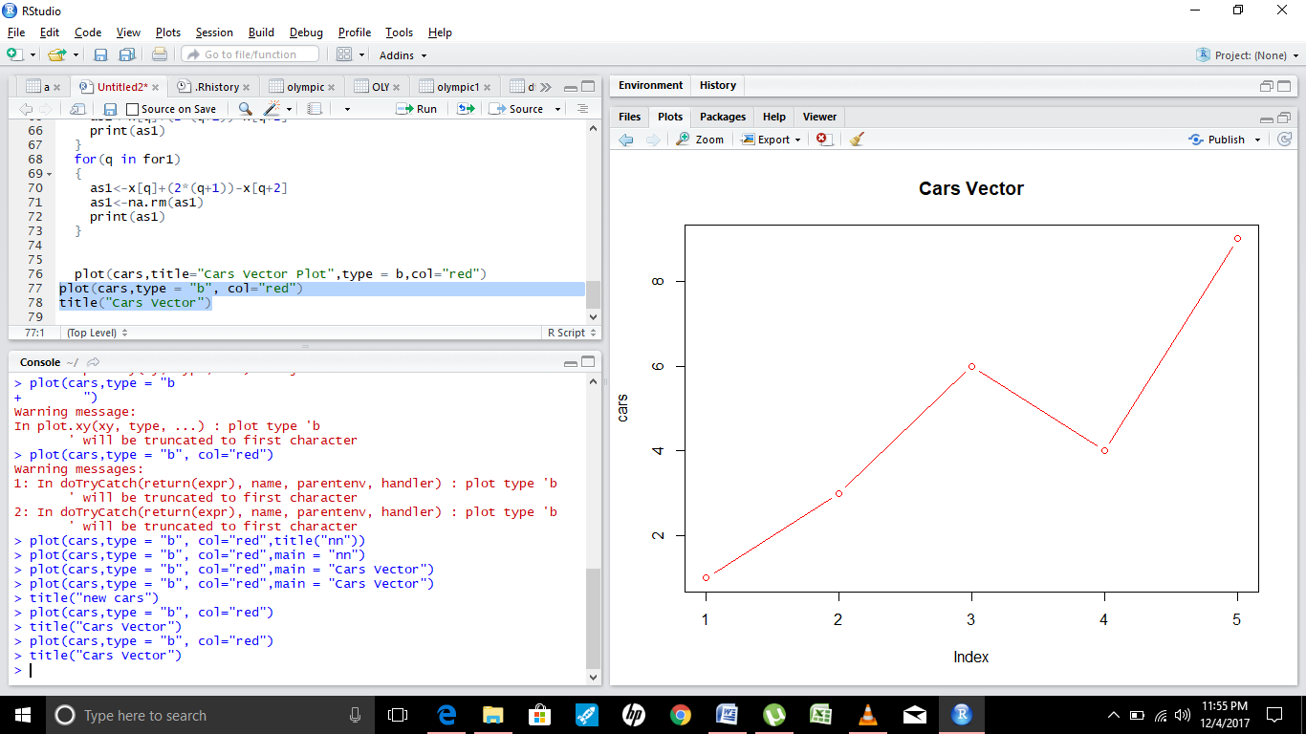

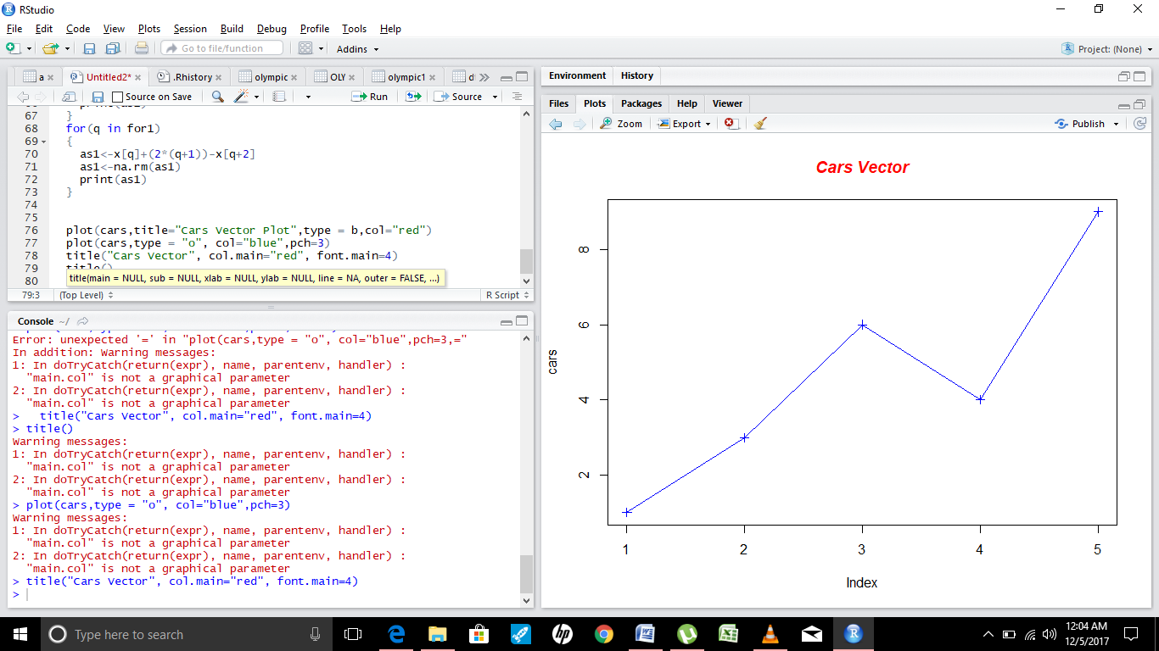

Q3.

Now let's add a red line for trucks and specify the y-axis range directly so it will be large enough

to fit the truck data:

• # Define 2 vectors cars <- c(1, 3, 6, 4, 9) trucks <- c(2, 5, 4, 5, 12)

• # Graph cars using a y axis that ranges from 0 to 12 plot(cars, type="o", col="blue",

ylim=c(0,12)

• # Graph trucks with red dashed line and square points lines(trucks, type="o", pch=22,

lty=2, col="red")

• # Create a title with a red, bold/italic font title(main="Autos", col.main="red",

font.main=4)

3.A

plot(cars,type = "o",col="blue",ylim = c(0,12))

3.b

|  |
| --- |
| lines(trucks,type="o",lty=2,pch=22, col="red") |
|  |
| |  | | --- | | 3.c  title("Autos",col.main="red",font.main=3,text.main=2) | |